Career Cluster Lesson Folder Checklist

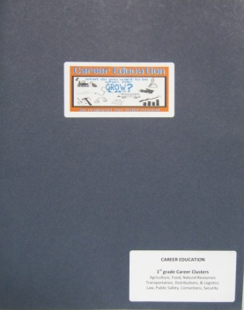
- Create 1 folder (grade level appropriate) for each classroom.
- Provide a “set” of folders (1/grade level) to school counselor.
These can be used to train students who are absent on the original date.
- Use 2-Pocket Portfolio Folder with fasteners.

Front of Folder

Item | Check if Complete
Printout of PowerPoint
Handouts 4 slides/page
(hole punch and place in fasteners)
Paws in Job Land Map
Grade-level cluster areas should be clearly identified
(place in left-hand pocket of folder)
Teaching Tips
Appropriate Grade-Level Teaching Tip Sheet
(place in left-hand pocket of folder behind map)
Stickers for Career Lessons
One for each student
(place in right-hand pocket of folder)
Elementary Bookmark
One for each student
(place in right-hand pocket of folder)
Activity/Coloring Page
Grade-level appropriate activity sheet
One for each student
(place in right-hand pocket of folder)
Grade-Level Cluster Label
One printed and placed on front of folder
(bottom-right corner---see picture above)
Career Lesson Sticker
One printed and placed on front of folder
(centered---see picture above)

