School Counselor Folder Checklist

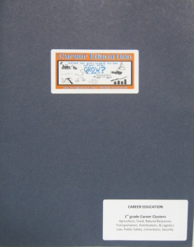
- Create 1 folder for the school counselor.
- This can be used to train students who are absent on the original date.
- Use 2-Pocket Portfolio Folder with fasteners.

Front of Folder

Item | Check if Complete
Printout of PowerPoints
Each grade level PowerPoint (1st-5th grades)
Handouts 4 slides/page
Separate each grade level PowerPoint w/ a colored sheet
(hole punch and place in fasteners)
Paws in Job Land Map
With all cluster areas clearly identified
(place in left-hand pocket of folder)
Teaching Tips
Appropriate Grade-Level Teaching Tip Sheet
Each grade level (1st – 5th grades)
(place in left-hand pocket of folder behind map)
Stickers for Career Lessons
2 sheets
(place in right-hand pocket of folder)
Elementary Bookmark
Qty of 15
(place in right-hand pocket of folder)
Activity/Coloring Page
Grade-level appropriate activity sheet
5 sheets for each grade level (1st – 5th grades)
(place in right-hand pocket of folder)
Counselor Folder Label
One printed and placed on front of folder
(bottom-right corner---see picture above)
Career Lesson Sticker
One printed and placed on front of folder
(centered---see picture above)
WBL Business Card
Place a business card on the left-hand pocket of folder

